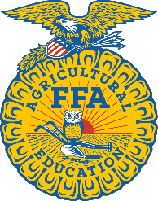
2023-2024 Agricultural Education
Incentive Grant for New Programs
Administrator Letter of Support & Acknowledgement

School District School Name
Administrator’s Name
Teacher’s Name (if applicable)
By signing this acknowledgement I, , understand that an application is being submitted on behalf of our school to be awarded a 2023- 2024 Agricultural Education Incentive Grant for New Programs.
If the agricultural education program at our school is awarded a 2023-2024 Agricultural Education Incentive Grant for New Programs, all funds must be used for the sole purpose of benefitting the agricultural education program, its students, and the teacher to enhance local delivery of a comprehensive, three-component agricultural education program. In addition, the eligibility for this grant requires that the school district be committed to implementing a comprehensive agricultural education program over the course of the next three years. This means that by June 2026, the school district will:
- Offer 2 or more agricultural courses by a *certified agricultural teacher
- Apply to charter an FFA chapter
- Allow students to take part in work-based learning, referred to as “Supervised Agricultural Experiences” (SAEs).

Administrator’s Signature Teacher’s Signature (if applicable)

Date Date

*Due to a shortage of certified agricultural teachers in New York State, a school may discuss the need for alternative measures if a certified agricultural teacher cannot be hired.

